BULLETIN ANNOUNCEMENT Example 2025-2026

Faith: Trusting in the God who waits for you.
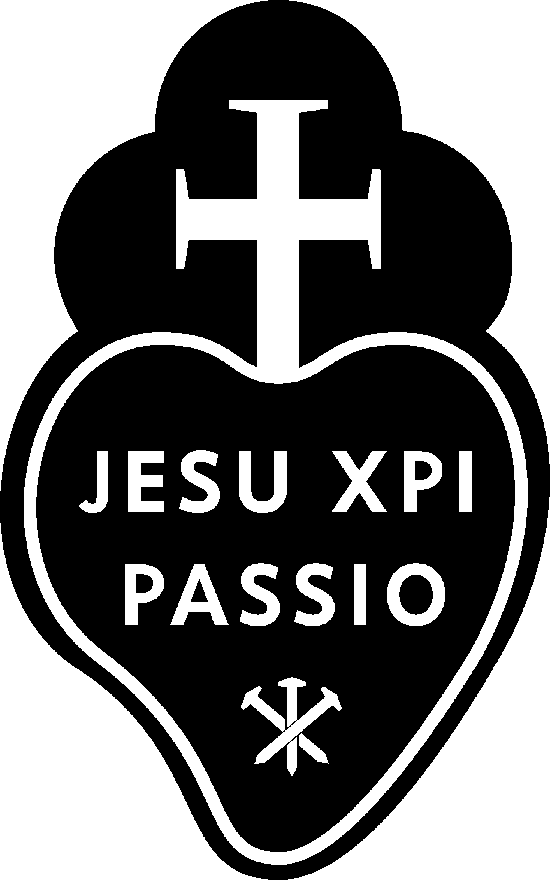 For nearly one hundred years the retreats at Mater Dolorosa Retreat Center have invited participants into a faithful, trusting relationship with the God who waits for us. This year’s retreat, Trusting in the God who Waits for You, the focus on faith as openness to the heart of God who waits long and always lovingly --- to touch our own hearts in deep and abiding relationship. God does not shout. God is present to us in what we see as graced moments, often in hindsight.
The Center provides a private room and bath, delicious meals, beautifully landscaped grounds and the guidance of the Passionist Retreat Team. The atmosphere of this silent, preached retreat will lay paths for this exploration. Mater Dolorosa Passionist Retreat Center invites the WOMEN of this parish to join on this epic adventure to the interior of our souls.
The date is: Example date: September 6-8, 2024. Reservations can be made directly at: https://materdolorosa.org/calendar/

Why come on retreat? QR code will show you a short video. 

