BULLETIN ANNOUNCEMENTS 2024-2025

Living the Paschal Mystery: Our Holy Hope
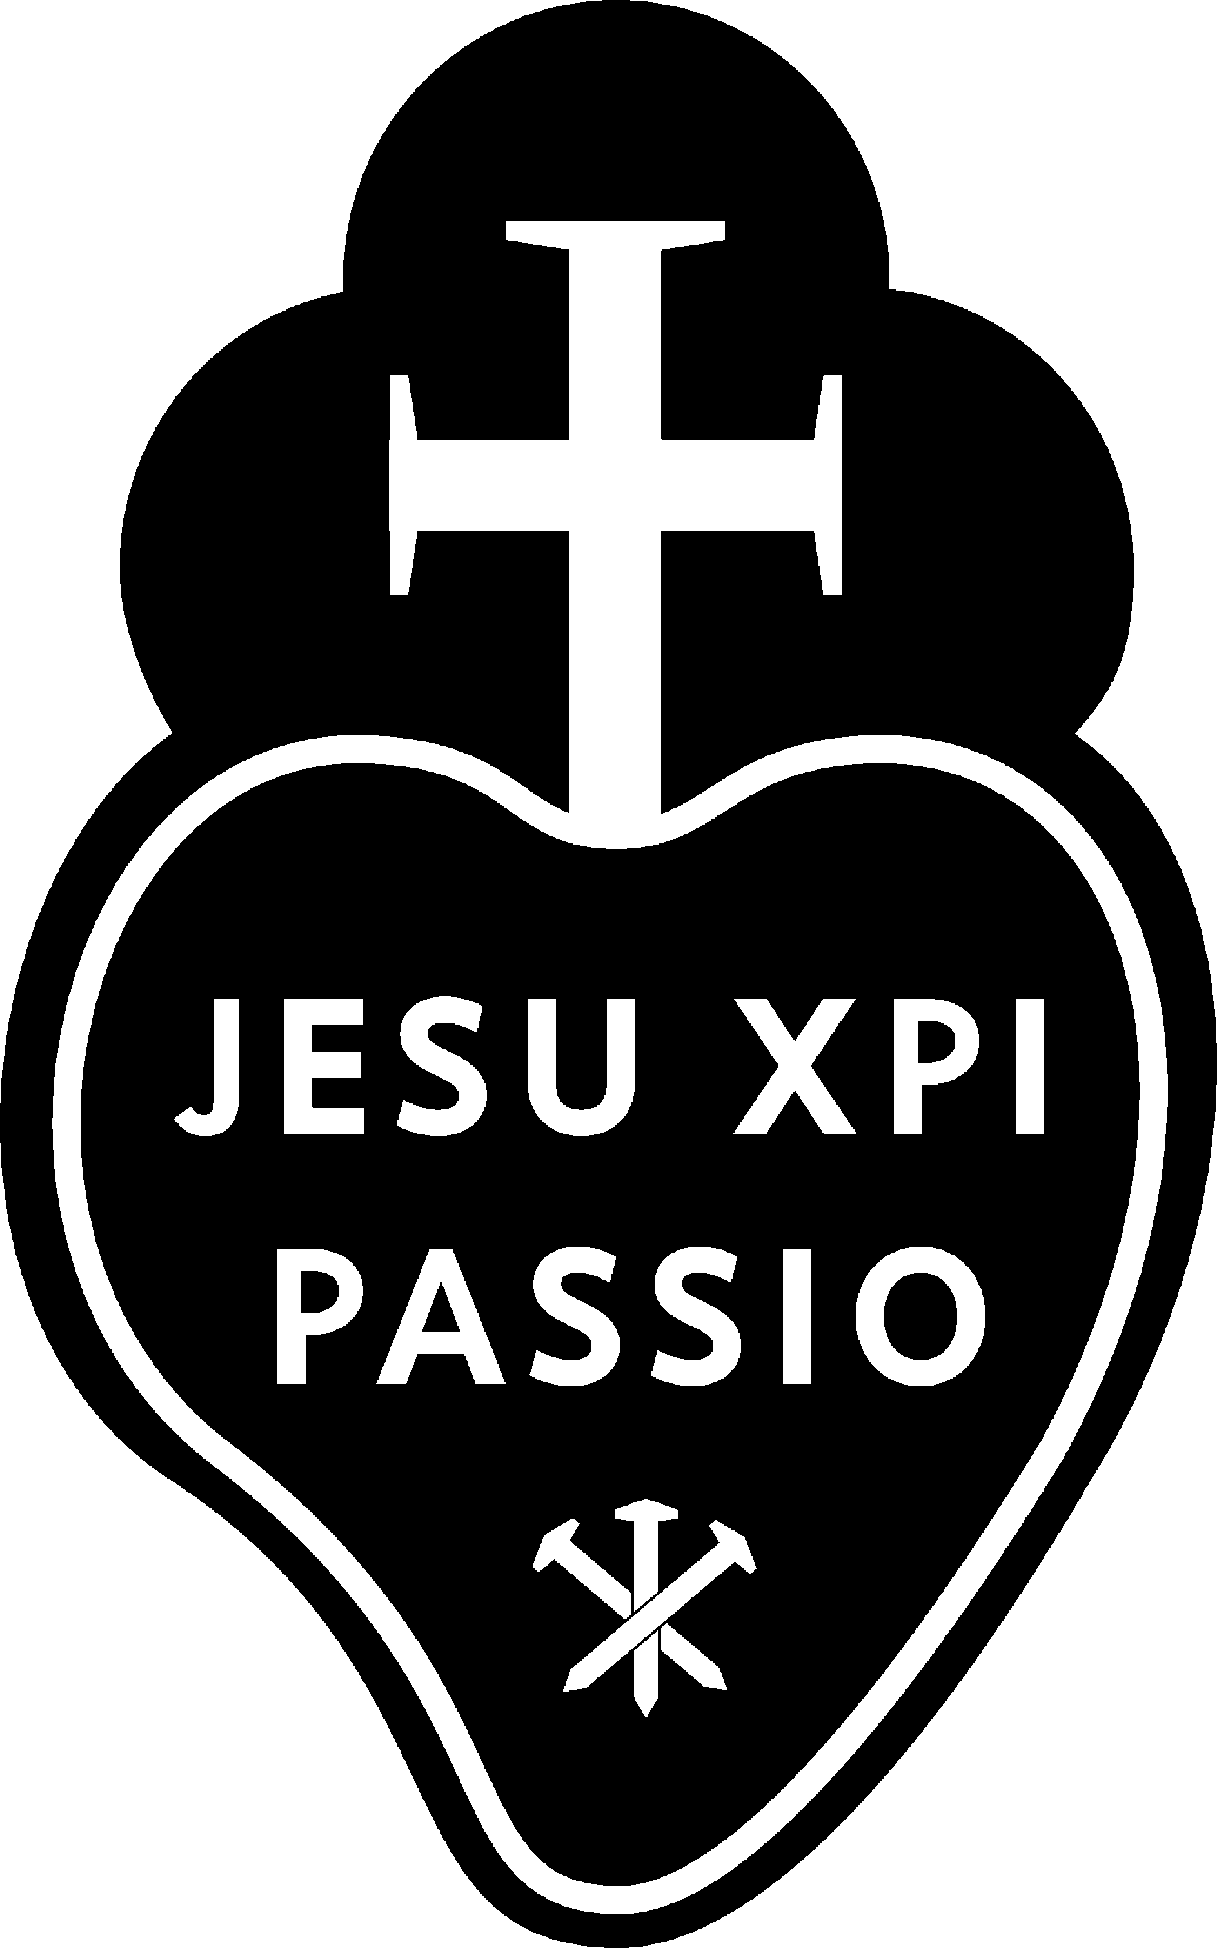 Living the Paschal Mystery calls us to active, ongoing engagement with the Spirit of God in Christ in our hearts, our communities, the church, and the world. The abundant love of Christ stirs in us the deepest kind of hope - not optimism -but a Holy Hope. Come to Mater Dolorosa. The Center provides a private room and bath, delicious meals, beautifully landscaped grounds and the guidance of the Passionist Retreat Team. The atmosphere of this silent, preached retreat will lay paths for this exploration. Mater Dolorosa Passionist Retreat Center invites the MEN of this parish to join on this epic adventure to the interior of our souls.
The date is: ____________ Reservations can be made by contacting our Parish Captain: ____________________________
Or you may register directly at: https://materdolorosa.org/calendar/

Why come on retreat? QR code will show you a short video. 

