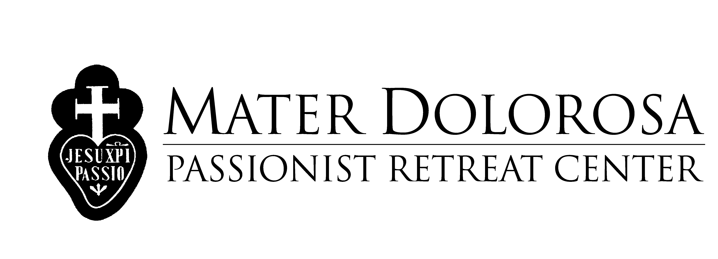

COVID-19 POLICY AT MATER DOLOROSA PASSIONIST RETREAT CENTER

Covid-19 has become a virus that we must all contend with after the initial pandemic and ensuing State of Emergency that was enacted in March 2020. While the State of Emergency is no longer in effect, Mater Dolorosa Passionist Retreat Center maintains the following practices and policies with regards to Covid-19:
- We continue to recommend guests who do not feel well to stay home and rest. Guests should test themselves before coming on retreat if they feel any symptoms such as a sore throat, cough, fever, congestion, etc. or have been exposed to anyone with
Covid-19. If you have been exposed to someone with Covid-19 please follow the Los Angeles Department of Public Health guidelines found at this link:
http://publichealth.lacounty.gov/acd/ncorona2019/covidcommunity/
- Anyone who tests positive for Covid-19 is asked to stay home until they test negative.
- Masks are not required indoors but can be worn by anyone who wishes to do so.
- Masks are not required outdoors.
- Guests who are not comfortable eating in the Dining Room may take their meal back to their room or eat outdoors on one of the verandas that have been set up for outdoors dining.
- The staff of Mater Dolorosa Passionist Retreat Center tests any time when they feel symptoms to ensure the safety of guests, staff, and the Passionist Community.
- Cleaning protocols follow CAL OSHA guidelines for Covid-19.

Mater Dolorosa Passionist Retreat Center
700 North Sunnyside Avenue
Sierra Madre, CA 91024
Telephone 626-355-7188
E-mail materdolorosa@materdolorosa.org
